Appointment of
Student Head of Form
Application Closing date: 5th October

The opportunity
We want to offer you the remarkable opportunity to represent your fellow students in driving forward our school. You would become the student voice that will play a pivotal role in the direction of the school.

You would become a part of our new School Council body that will meet throughout the year to discuss the most important issues of the school with the school’s leadership team. As a part of the Council you would get the opportunity to develop your own skills in leadership, public speaking, team work and debate – skills that future colleges and employees regularly ask for from potential applicants.

What we are looking for?
- Most importantly we are interested in students who are passionate about their education and about making a difference in their school.

- Students who apply should be able to follow a strict Code of Conduct which requires you to have excellent attendance, outstanding attitude to learning and behaviour, while also being an exceptional role model to your fellow students.

- We want students who are confident at building relationships with other students and communicating ideas to a range of audiences such as your peers, teachers, and senior leaders. You should also be able to discuss ideas within a group, be tolerant of other’s suggestions and work well in teams.

If that sounds like you, and you want to be challenged in a supportive environment and believe that together we can make Rastrick High School and even better place to learn then please apply to be part of our team.
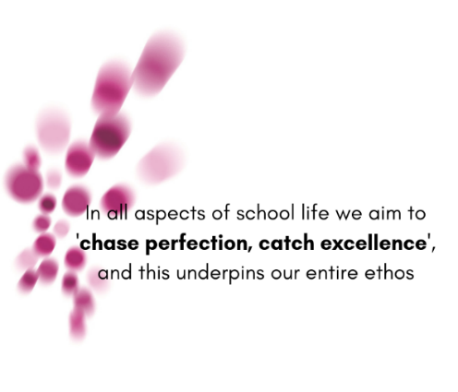

Student Head of Form
Job Description
What is the core purpose of the role?
- To play a pivotal role in the direction of the school improvement.
- To represent all students within your form group and be their voice on the Student Council.
- To work with senior leaders and teachers to implement the ideas voiced by students.

Who will you report to?
As a member of the Student Council you will report to Mr Waterworth and the other senior leaders in the school.

Who will you be working with?
As a student Head of Form, you will be expected to work with your form group to lead discussions and collect ideas about what students want.
As a member of the Student Council, you will work with the student Heads of Year and Mr Waterworth.

What will you be expected to do as Head of Form?
There are a wide variety of roles you will be expected to fulfil as Head of Form. These will include:
- Lead discussions on issues and ideas of improvement around your year.
- Take minutes of meetings so there is a record of what was discussed which can be shared with all stakeholders.
- Act as a representative for the school while showing guests around the building
- Deliver presentations and speeches to form groups about new initiatives/ideas you have helped to create
- To always act as role models to other students around the building and in lessons

What benefits do you get?
- Access to the Leadership Zone when restrictions are lifted.
- First hand experience of helping to mould the school’s vision for its students
- Opportunities to develop skills desirable for future college/university/employees

