Appointment of
Student Head of Form
Application Closing date: 28th September
Presentations: W/C 3rd October

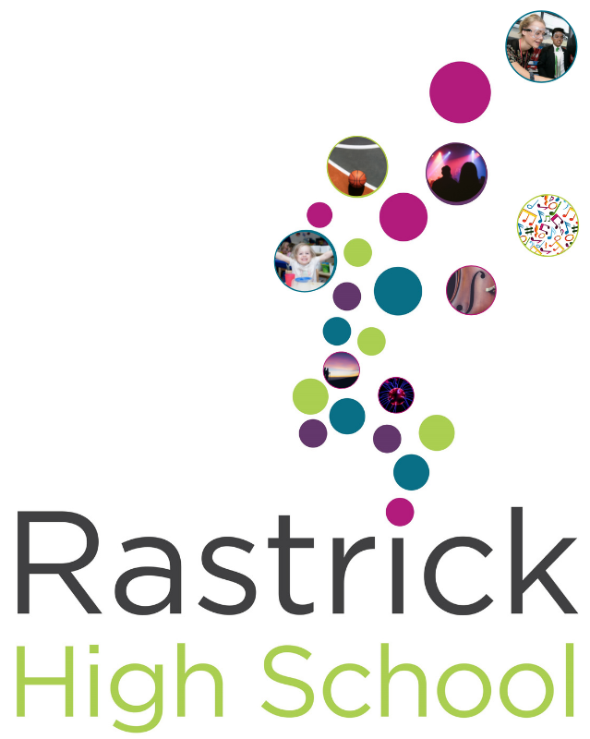
The opportunity
We want to offer you the remarkable opportunity to represent your fellow students in driving forward our school. You would become the student voice that will play a pivotal role in the direction of the school.

You would become a part of our new Student Leadership team that will meet frequently to discuss the most important issues of the school with the school’s leadership team. You will also get the opportunity to develop your own skills in leadership, public speaking, team-work, confidence and debate – skills that future colleges and employees regularly ask for from potential applicants.

What we are looking for?
- Most importantly we are interested in students who are passionate about their education and about making a difference in their school.

- Students who apply should be able to follow the Rights and Responsibilities which we have as a school, which requires you to have excellent attendance, outstanding attitude to learning and behaviour, while also being an exceptional role model to your fellow students.

- We want students who are confident at building relationships with other students and communicating ideas to a range of audiences such as your peers, teachers, and senior leaders. You should also be able to discuss ideas within a group, be tolerant of other’s suggestions and work well in teams.

If that sounds like you, and you want to be challenged in a supportive environment and believe that together we can make Rastrick High School and even better place to learn then please apply to be part of our team.

